Please follow instructions below if you get errors that are related to ThinPrint, such as the 'Virtual Channel' error.

1.) Close all Internet Explorer windows.

2.) Go to START, then open the Control Panel. (Depending on your Menu setting, you may have to go under Start, Settings, and then Control Panel.)
- Click on Add or Remove Programs
- Remove ThinPrint. It most likely is the first item on your list .Print Client Windows (ICA)
- Also remove Metaframe Presentation Server or Citrix XenApp Client
- Once these two programs have been removed, you can close the Add/Remove Programs window.

3.) Open Internet Explorer
- Go to https://vo1.c-sgroup.com
- Log in with the security token (fob)
- At the bottom-right of the page, there are 2 links:
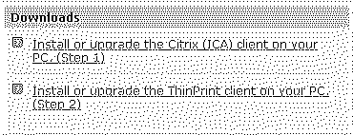
1) Run "Install or upgrade the Citrix (ICA) client on your computer. (Step 1)" first. Follow the prompts.
2) Once the ICA install is done, run "Install or upgrade the ThinPrint client on your computer. (Step 2)"

After the ThinPrint install window disappears, close all internet explorer windows again. Log back into https://vo1.c-sgroup.com. Printing should now work.

